
FAMILY SUPPORT HUB REFERRAL FORM
ALL INFORMATION MUST BE COMPLETED IN FULL TO ENSURE FAMILIES ARE SIGNPOSTED TO THE APPROPRIATE SERVICE
ANY FORMS RECEIVED WITH MISSING INFORMATION WILL BE RETURNED TO REFERRER FOR COMPLETION
Referrer Details
REFERRER NAME |  |  |  |  |  |  |  |  | DATE OF REFERRAL
REFERRAL AGENCY |  |  |  |  |  |  |  |  | ADDRESS
DESIGNATION |  |  |  |  |  |  |  |  | ADDRESS
TEL |  |  |  |  |  |  |  |  | EMAIL
Hub Locality (Tick) |  |  | Armagh & Dungannon |  |  |  |  |  | Craigavon & Banbridge |  |  |  |  | Newry & Mourne
Family Details
 |  |  | Mother |  |  |  |  |  |  |  |  | Father
Name
Address

Postcode
Tel No

Parent’s Date of Birth

Disability Yes/No
Please state type
Ethnicity

Name of Child/ren requiring service |  |  | M/F |  |  | DOB |  | Disability Y/N ?  If yes ,state type |  |  |  |  | School
 |  |  |  |  |  |  |  | Y/N
 |  |  |  |  |  |  |  | Y/N
 |  |  |  |  |  |  |  | Y/N
 |  |  |  |  |  |  |  | Y/N
Ethnicity |  |  |  |  | Language Needs (interpreter required)
GP Details

Details of Family Background – including other siblings, significant family members.
State main presenting reason for referral to Family Support Hub
Other organisations known to be involved with the family and support services received and/or declined to date by family


Outline specific type of support being sought
CONSENT

Consent to hub referral
(Please note the referral cannot be considered unless explicit consent has been given)
I consent to this information being shared at a meeting of core hub members with the purpose of agreeing suitable supports for me/ my family. The Family Support Hub referral process has been explained to me and an information leaflet provided. I understand that my consent is voluntary and if at any stage of the process I wish to withdraw my consent I can do so, by contacting the hub coordinator in my area, details below.
Data Protection consent
The information you provide on this form will be held electronically for up to 3 years. We will take all steps necessary to ensure that this is securely held/archived/destroyed. You have the right to request a copy of the information that the respective Southern Family Support Hub holds on you. To do so, either you or an authorised third party must request this in writing to:
Data Protection Officer, at the appropriate hub organisation address outlined below.
Parent |  |  |  |  |  |  |  |  |  |  |  |  |  | Date:
Parent |  |  |  |  |  |  |  |  |  |  |  |  |  | Date:
Young person (if over 16 yrs.) |  |  |  |  |  |  |  |  |  |  |  |  |  | Date:
NOTE for referrers:
Where there is no signed parental consent you are required to sign to confirm that you have informed the family of the hub process and that the parent is consenting to the sharing of the information included on this form

Referrer Name |  | Date

This form can be returned by post or email to the Family Support Hub in your locality.
ARMAGH/ DUNGANNON HUB  Caroline Williamson  Barnardos  Grange Building, Tower Hill, Armagh,  BT61 9DR  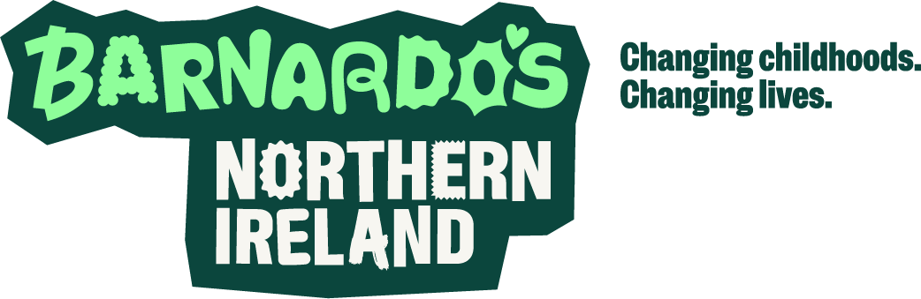  Tel: 02837 414541  07514 724926  Email: familysupporthub@barnardos.org.uk |  |  |  | PORTADOWN/ CRAIGAVON/  BANBRIDGE HUB  Lisa Grant/Ronan Garvey  Early Intervention Services  (NIACRO)  26 Carleton Street, Portadown  Co Armagh, BT62 3EP    Tel: 02838331168  Email: familysupporthub@niacro.co.uk |  |  |  |  |  |  | NEWRY & MOURNE HUB  Jacinta Linden  SPACE  24 Monaghan Street,  Newry, BT35 6AA  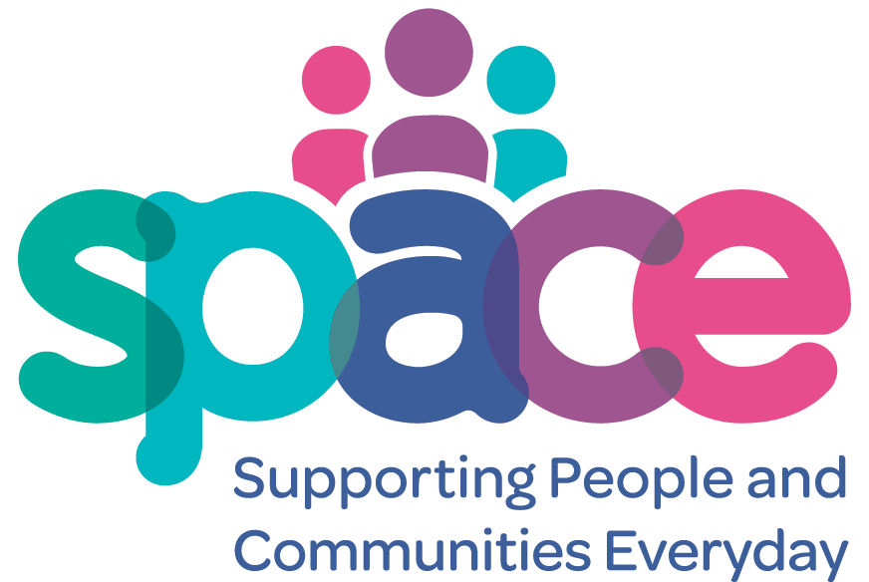  Tel: 02830835764  Email:  familysupporthub@space-ni.com

You may wish to view the Southern Trust Family Support Hub DVD via the following link:
https://vimeo.com/216493917

